

Monthly Hydro Meteorology Bulletin
2026

Forward

This Monthly Hydro Meteorological Bulletin is prepared and disseminated by the Ethiopia Meteorological institute (EMI). The ultimate objective of producing and disseminating this bulletin is to inform all level decision makers with the updated and relevant hydro meteorological information. This monthly Bulletin reviews the March 2026-month climate condition and its impacts over the river catchment across the country and highlights the April 2026 climate outlook along with the likely impact over the water dams and the rivers basins.
The information contained in this bulletin is believed to assist the water professionals for planning the capacity expansion of reservoirs, water supply, ecosystem restoration as well as rehabilitation of existing systems including dams, irrigation, canals, pumps, wetlands and the likes. In addition to the aforementioned benefit the bulletin also reveals the aridity levels of each basin, extremes heavy rainfall events and areas where significant amount of moistures loss through evapotranspiration. In the impact outlook section of the bulletin it provides the likelihood of the climate in the coming month and its potential impact over various aspect of the river basins including the hydraulic structures such as culverts, bridges, reservoir spillways, road embankments and dikes. It also indicates the measures need to be taken as the early actions so as to reduce the possible negative impact of the upcoming month climate condition. Meanwhile, your comments and constructive suggestions are highly appreciated to make the objectives of this bulletin a success.

1. Introduction 3
1.1 Monthly Hydro Meteorological Assessments 4
1.1.1 March Monthly Climatology of the Ethiopian River Basin 4
1.1.5 Distribution of Heavy fall 8
2. Hydro Meteorological Impact Outlook for April, 2026 1
2.1 Expected weather impact on water resource during the coming April 2026 1

Introduction

The provision of hydro meteorological services can contribute a significant role toward water resource management and socio economic development. Both surface water and groundwater management are essentially linked to climate variability. Therefore, the provided climate information and knowledge in this monthly hydro meteorological bulletin have a critical importance for efficient, equitable and sustainable development and management of the national water resources and for coping with any climate related risks. The information illustrates the impact of previous month climate on each and every water basins and the associated climate risks observed during the month under review. In addition to the previous month impact assessment, the bulletin also provided the expected climate condition for the coming months and its impact on the water resource. The design of water-use and flood-control facilities, mainly dams and reservoirs, is frequently based on these analyses. Estimating the likelihood of precipitation, the distribution of precipitation and the rate of evaporation in location and time, the heavy rainfall and the subsequent runoff, extreme temperature and wind are among issues that hydro meteorologists are concerned with.

1.1 Monthly Hydro Meteorological Assessments

1.1.1 March Monthly Climatology of the Ethiopian River Basin
As can be seen in figure 1, most parts of Omo Gibe, Rift valley, Baro Akobo, Awash, Genale Dawa, upper and middle Wabi shebele and, Abay, few area border of Afar Danakil, receive significant amount of moisture exceeding the potential evapotranspiration of the areas. In climatologically the south western, southern and portion of south eastern basin experienced sub humid to Humid. And the rest northern, north eastern and eastern climatological dry, such as most of Ogaden, Tekeze, wabi shebele, lower Abay, middle and lower Genale Dawa Ogaden, and Afar Danakil.
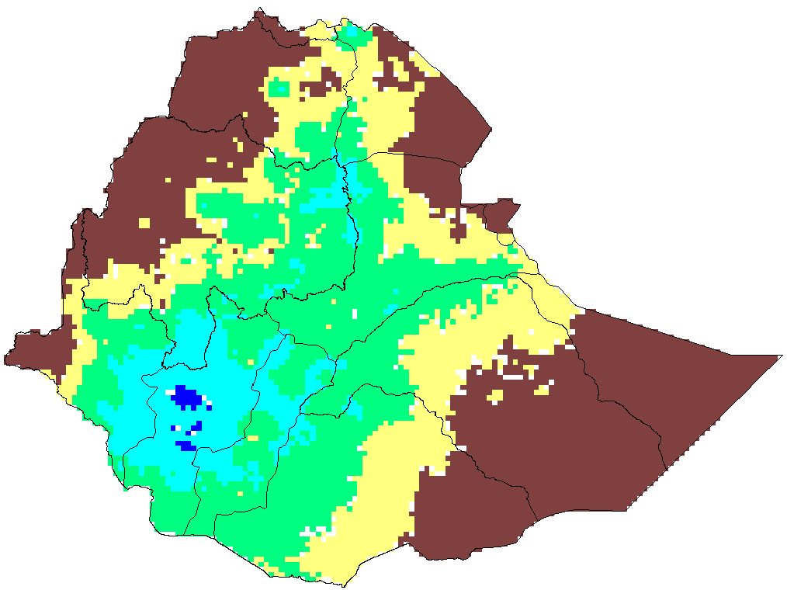
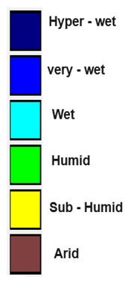

Figure 1. March Monthly climatology of the Ethiopian river basin

1.1.2 March 2026 Rainfall Assessment over the River Basins
During March 2026, the observed rainfall over the basin illustrated in figure 2, a better monthly rainfall distribution is observed across the southern, southeastern, central, southwest, and western. The result shown over the most parts of Omo Gibe, Baro Akobo, Rift Valley, Genale Dawa, Ogaden, Upper and Middle A wash basins experienced 60.4-302 mm of rainfall and in addition upper Baro Akobo, middle and lower and Omo Gibe and Rift valley, upper Genale Dawa have received 303-422 mm. The other, most of Afar Danakil, Abay, Aysha, few area of lower Awash basins have received below 60.3 mm rainfall.
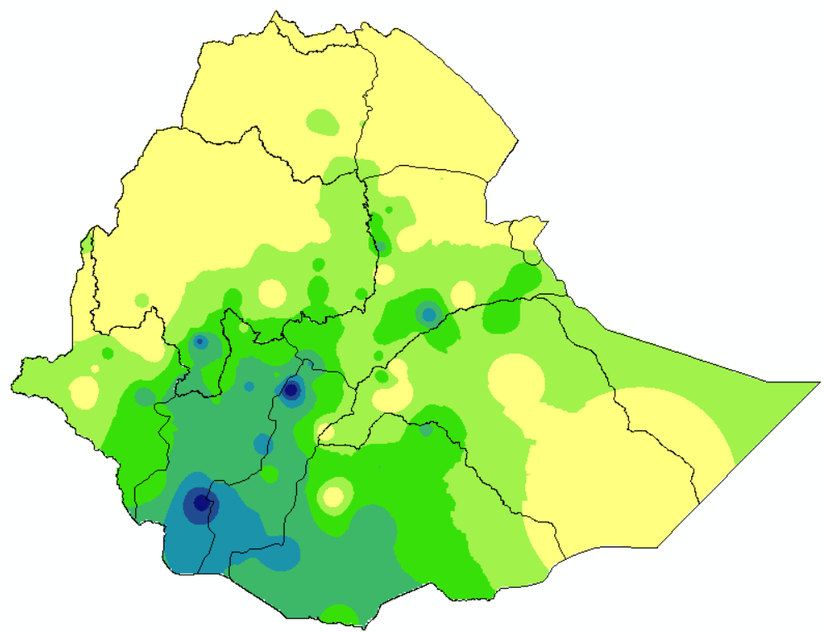
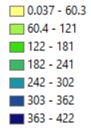

Figure 2 March monthly mean rainfall over Ethiopian River Basin

1.1.3 Monthly Mean Temperature over the River Basin
During March, 2026, the observed mean temperature, as shown in Figure 3, was below 22°C in the majority of the central catchments, including in some part of most of Abay, Omo-Gibe, Rift Valley, Tekeze, Genale-Dawa, upper and middle Wabisheble, upper Awash, basins have lower evapo-transpiration. However, the monthly average temperatures reported in the Ogaden, middle and Lower Awash, Baro Akobo, Wabi shebele, and Genale Dawa, catchments were above 22.68°C.
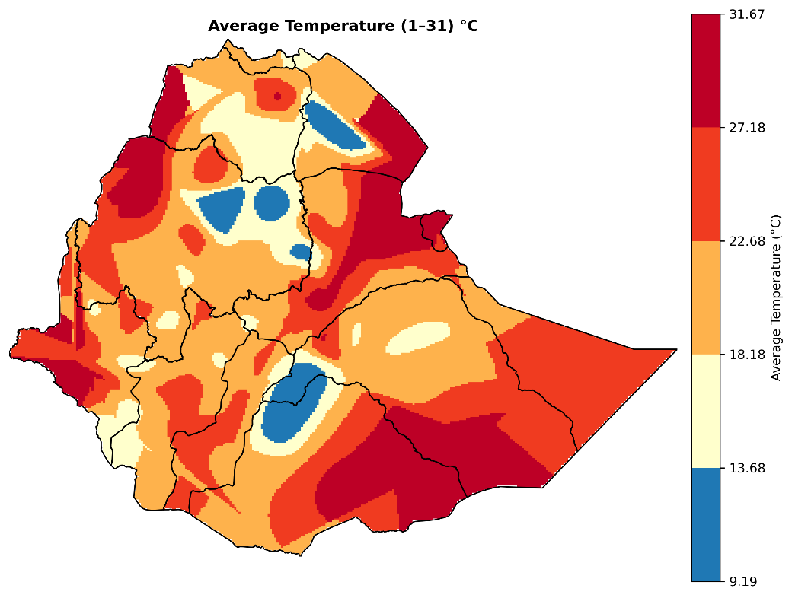

Figure 3 March monthly mean temperature over Ethiopian River Basin

1.1.4 Assessments of Aridity Index during the month of March
During March 2026, the observed Aridity Index is shown in Figure 4. The results indicate that the southern, south western, central, and southeastern part of the basins have significant distribution of surface water. This is evidenced by the sub humid to hyper wet Index observed in the most of the Baro Akobo, Omo Gibe, Rift Valley, wabi shebele, Ogaden, Afar Denakile and Genale Dawa, upper and Lower Abay, Upper and Middle Tekeze, Aysha and Mereb Gash .

Figure .4 March monthly Aridity index

1.1.5 Distribution of Heavy fall
As can be seen in the above figure 4, some of Belg moisture benefiting Basin such as Omo Gibe, Genale Dawa, Wabi shebele and Rift Valley in additionally Awash, Abay, and Tekeze basins are records one day up to six day in different stations in this month. This frequency of rainfall will be increasing water holding capacities for dams and other reservoir.


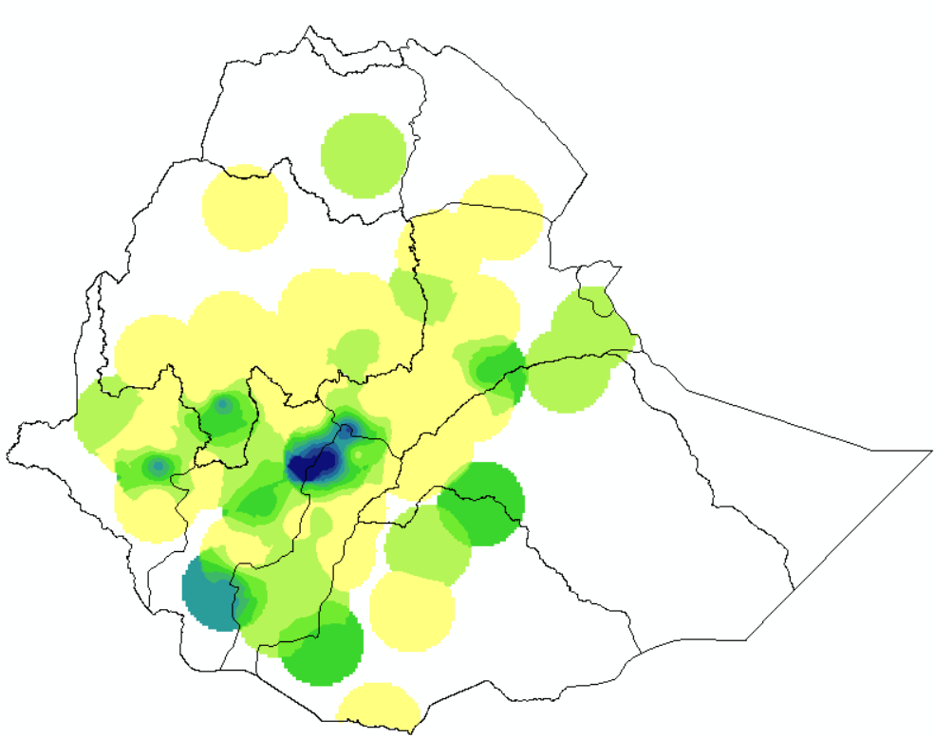

Figure 5.Heavy Fall Frequency over Ethiopian River Basis

2. Hydro Meteorological Impact Outlook for April, 2026

2.1 Expected weather impact on water resource during the coming April 2026

The next April month will have expected to bring better surface water flow in belg benefiting basins and other basins. In addition, better surface water flow is expected best distribution than in the previous two monsoon seasons. This is of great benefit to irrigation and power generation as well as to improve drinking water supply, in general, residents in flood-prone areas are urged to remain alert for possible floods, flash floods, and poor visibility. Given the anticipated high water levels in rivers, lakes, and dams, Furthermore, individuals living in landslide-prone areas, especially in hilly regions, are strongly encouraged to remain watchful during this period. On the other hand, the expected low surface water flow in the Afar Danakil, Ogaden, Middle and Long Tekeze, MerebGash and Aysha basins is due to water scarcity and reduced water levels in dams and reservoirs. The main reasons for this are the lack of rain water resources, water conservation and pollution free pre-emptive measures.

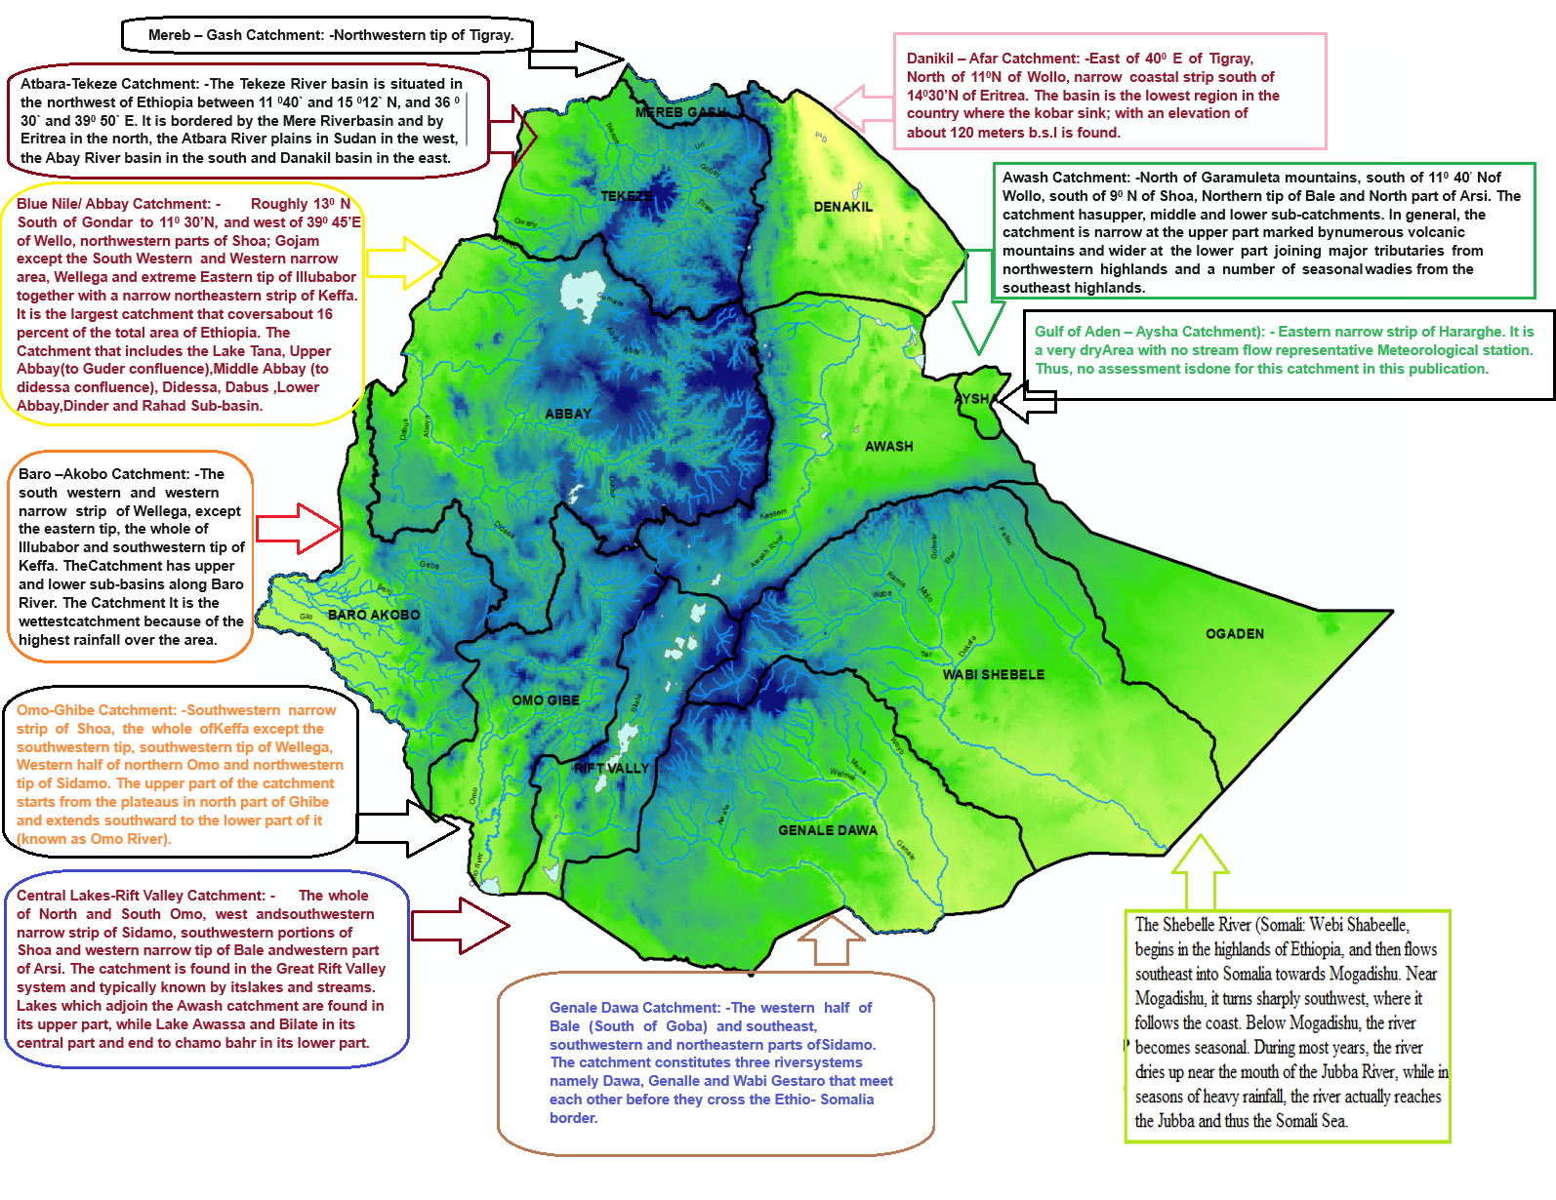
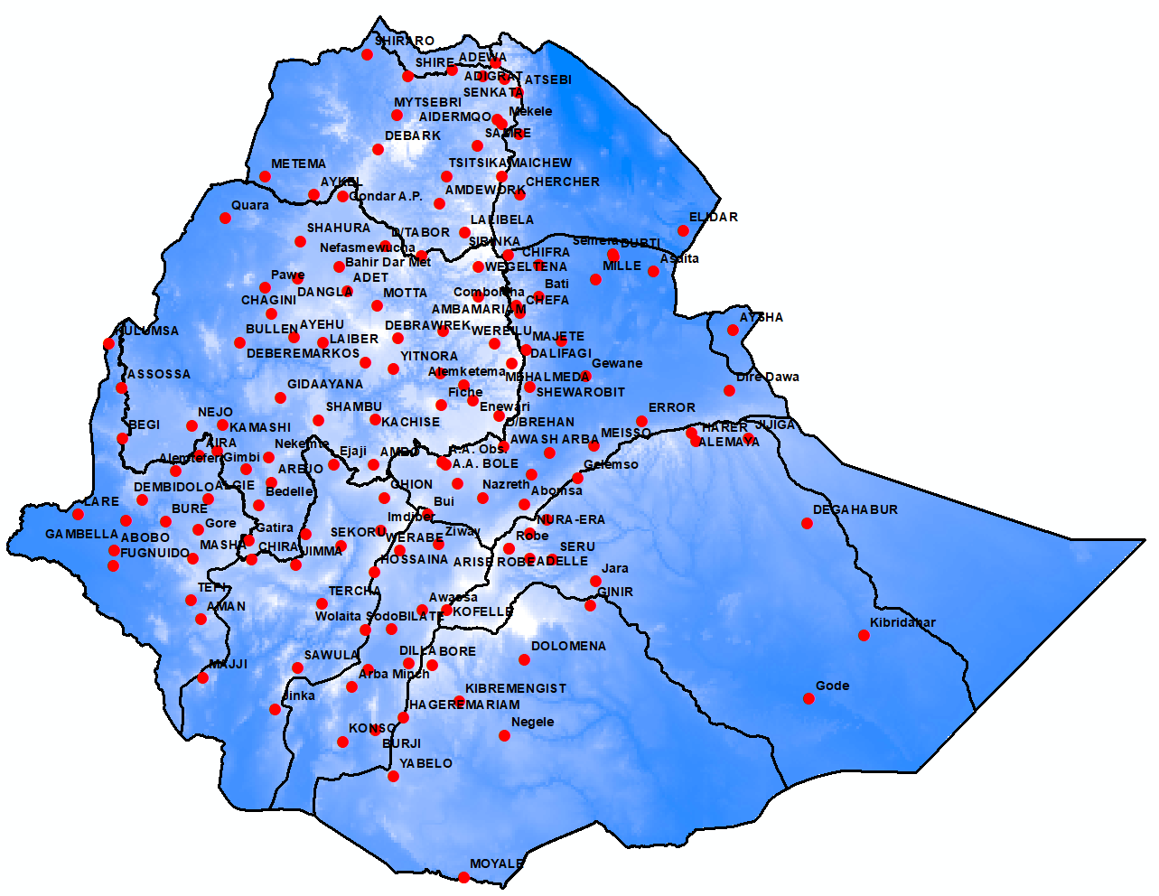
Number of station

