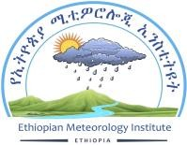

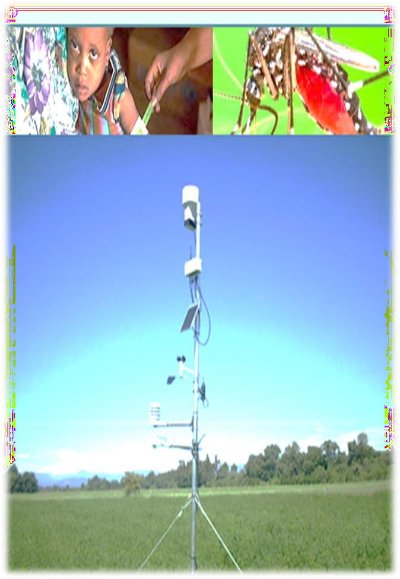

Ethiopian Meteorology Institute

Health-Meteorology Bulletin

The product of Biometeorology and insurance desk

## Decadal Bulletin

**Volume**: 12

: 01/12/2024

: 20/01/2025

## December 2024

**©*Ethiopian Meteorology Institute***

: 251(0)11 6615779

: 251(0)11 6625292

1090

<http://www.ethiomet.gov.et/>

https://t.me/BiometService





**Table of Contents**

1. Foreword ……………………………………………………………………………………… 3
2. Assumptions 4
   1. Malaria 4
   2. Human heat index: 4
   3. Cattle heat index: 4
3. Weather impact Assessment on Health for 1st Dekad of December 2024 5
   1. Malaria prone areas during 1st Dekad of December 2024 5
   2. Climate comfort Conditions 5
      1. Human Comfort Index 5
      2. Cattle Comfort Index 5
4. Expected Weather Impact on Health for 1st dekad of December 2024 6
   1. Expected Mosquito breeding areas 6
   2. Temperature Humidity Index 6
      1. Human Comfort Index 6
      2. Cattle Comfort Index 6
5. Summary 7
6. Advisory 7



# Foreword

This "Climate Information for the Health Sector" Bulletin has been designed to convey essential information regarding the monitoring of human comfort conditions based on the analysis of temperature and humidity data and also for the monitoring of Malaria outbreak areas based on the analysis of temperature and precipitation data. Since the monitoring of temperature and rainfall over a given area can be used to assess the likelihood of outbreak of Malaria with a lag of two months, this information can be an important for early warning tool if used judiciously.

The major objective of this bulletin is in line with the Ethiopia Meteorological Institute strategy of diversifying climate application products to the basic developmental sectors (such as the Health, the water, the agricultural sector etc…). This bulletin can be a very important source of information to Health professionals engaged in the monitoring of Public Health, to Tourism Agents and institutions who advise tourists regarding the comfort conditions of the places to be visited by the tourists and to the researcher who is interested in the field of Bio-Climatology.

We have the opinion that careful and continuous use of this bulletin can benefit to the improvement of early warning and preparedness in the Heath sector.

Meanwhile, your comments and constructive suggestions are highly appreciated to make the objective of this bulletin a success,

This same bulletin can be accessed online at[: http://www.ethiomet.gov.et/bulletins/health_bulletin](http://www.ethiomet.gov.et/bulletins/health_bulletins)s

Director General

Ethiopia Meteorology Institute P.O.Box 1090

Tel: 251(0)11 6615779

FAX 251(0)11 6625292

Web: [www.ethiomet.gov.et](http://www.ethiomet.gov.et/) Addis Ababa, Ethiopia





# Assumptions

1. **Malaria:** According to the International Research Institute for Climate and Society, (IRI), the predicted conditions of rainfall, temperature, and relative humidity are used in determining the degree of incidence for malaria.
   * When rainfall is above 80 mm, the temperature is between 25°C and 320C, and relative humidity is greater than 80%, the region is at high risk and is placed under high incidence.
   * When the temperature is between 20°C and 25°C, relative humidity is between 70 and 80%, and rainfall is above 80 mm, then moderate incidence is advised.
   * Low incidence for malaria is issued when the temperature is in the range of 180C-20°C, relative humidity is 60 - 70% and rainfall is above 80 mm.
   * No incidence is required when the temperature is less than 18°C, relative humidity less than 60%, and rainfall amount below 80 mm.

Based on these, climate variables have ***a one to two months*** postponed (delayed) effect on the spread

of malaria.

1. **Human heat index:** is a measure of how hot it feels when relative humidity is factored with the actual air temperature. The levels of caution for heat index are classified as follows:
   * Cold stress when THI is <14, ***Asthma, Pneumonia, Common Cold and flu***
   * Comfortable when THI is 14-21, ***pleasanter***
   * Moderate when THI is 21-26, ***No more effects***
   * Heat stress when THI is >26, ***heat stroke, heat cramps, hyperthermia, respiratory and cardiovascular diseases***
2. **Cattle heat index:** The climatic condition for Cattle is a measure that accounts for the combined effects of environmental temperature and relative humidity on cattle. The level of heat stress for cattle classified as follows:
   * Not Stressed when THI is <68, ***free from heat stress***
   * Stressed threshold when THI is 68 – 71, ***impact less stress starting***
   * Mild stress when THI is 72 – 79, ***stress begins and calf rate affected***
   * Moderate stress when THI **is** 80 – 89, ***Milk production affected***
   * Severe stress when THI is 90 – 99, ***very significant losses in milk production***
   * Extremely stress when THI is >100, ***ultimate dead of cows***

# Weather impact Assessment on Health for

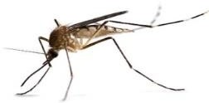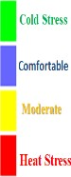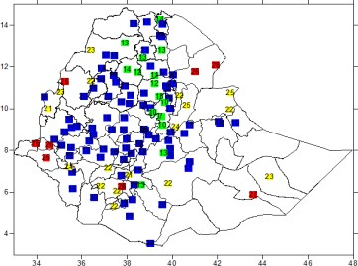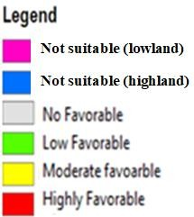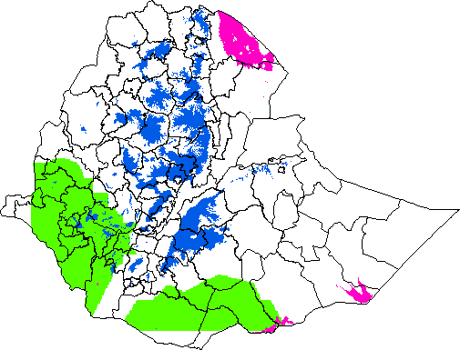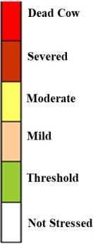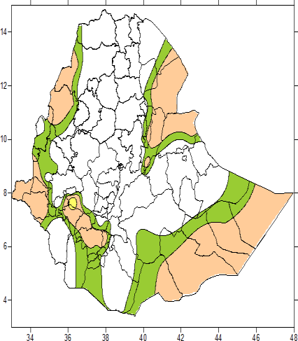

# 1st Dekad of December 2024

## Malaria prone areas during 1st Dekad of December 2024 month

As of the climate condition of 1st Dekad of December 2024, there was a low favorable climate condition for malaria transmission. According to the analysed climate data, but west**, Kellem wellega and Illu Ababora, zones of oromia region, Itang and Majang zones of Gambela region, Sheka, bench Sheko, Mirab Omo, Kefa, Dawuro and Konta zones of South-west Ethiopia region, Basketo, Gofa and South Omo zones of South Ethiopia** regions will be in low risk of malaria transmission for the coming one- to-two months. But keep in mind that this climate analysis is the current climate situation, which means the impact of last favorable climate condition will add more impact on the listed zones and also other parts of the country which was suitable during the last one-to-two months as illustrated in figure 1.

Figure 1: Malaria Prone areas

## Climate comfort Index

### Human Comfort Index

For the daily activity of human beings, the climate during 1st Dekad of December 2024 was very pleasant for most parts of the country. But in some high lands of the northern, southern high land and central parts of the country there were been cold/dry weather condition in the morning and evening times and also there were heat-stress climate condition in the **western and eastern low lands of the country like Gambela, Afar, Southern Somali and Benishangul Gumuz regions** as shown in figure .

Figure 2: Human comfortable index

### Cattle Comfort Index

During the month Non-significant heat- stress(sign of heat-stress-begin) was observed in the low land border parts of the country; like **Afar, southern Somali, Gambela, border of Benishangul Gumuz and western Amhara (Quara woreda**) as shown in figure 3.

Figure 3: Cattle Comfort index

## Expected Mosquito breeding areas

In the coming ten days of December 2024, Most of the country favorable climate condition for mosquito breeding and development will not expected. But

**South Omo, Basketo, Gofa, Mirab Omo, Bench sheko, sheka, kefa, Majang, Illu Aba Bora, West and East Wellega, Kamash, West Gojam and South Gonder zones o**f the country will be under favorable weather for malaria as illustrated in figure 4.

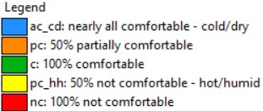

Figure 5: Expected Human comfort index

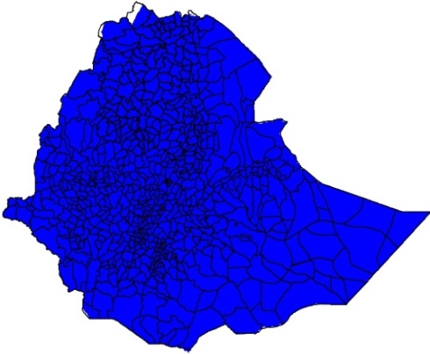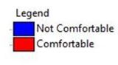

### 2.2.2 Cattle Comfort Index



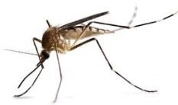

**2. Expected Weather Impact on Health for**

**Second dekad of December 2024**

Figure 4: Expected malaria prone areas

## Temperature Humidity Index

### Human Comfort Index

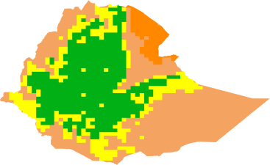

For the coming December 2nd Dekad, there will be pleasant weather condition over most parts of the country except **Northern-Afar, Eastern-Gambela, Southern-Somali and southern parts of South Ethiopia** regions, which will be partially to fully not comfortable for humans daily activity (sign of heat stress expected) and North, northeastern and southern high land area which will be nearly comfortable (cold/dry) as looking in figure 5.

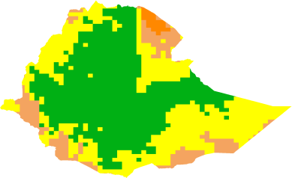

Like the human comfort index, cattle’s comfort index for the next ten days of December will have no significant heat stress over the country. However, the country's **lowland-border parts** will be in moderate heat stress conditions, as shown in Figure 6.

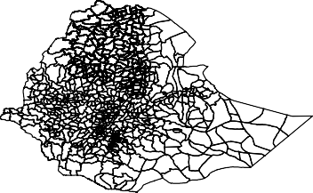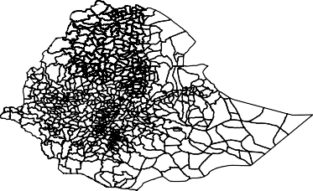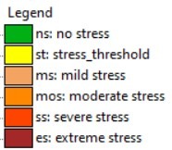

Figure 6: Expected Dairy (***Top***) and Non-

Dairy (***Bottom***) Cattle comfort index



# 3. Summary

Based on the climate-health analysis for December First Dekad it has been observed that, there were low suitable climate conditions to the breeding and transmission of malaria in South-western and Southern parts of the country. Similarly, over the next 10 days of December 2024 Second dekad, In some pocket areas of western, south-western and Northern parts of the country will continue to experience expanded suitable conditions for the breeding and development mosquitoes.

In terms of climate comfortability conditions, most parts of the country have experienced pleasant conditions for both humans and livestock. Looking ahead to the next 10 days of December 2nd dekad, the low-lying border areas of the country, especially afar, southern Somali, and South Ethiopia will experience moderate heat stress, which will affect both humans and cattle And also in North, northeastern and southern high land area which will experience cold stress.

# 

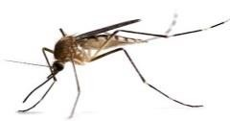

# Advisory

Use and implement the following recommendations in places that are favorable for the development of malaria and other vector-borne related diseases;

 Attention to any incidence, especially for malaria disease in such favorable areas

 Controlling measures and activity are advised

 Reducing the environmentally aggravating condition

 Awareness creation campaign to the community and sharing of the climate-health update

* Avoid any exposure of the community to mosquitoes by ensuring clean environment and using Mosquitoes nets.

Dress appropriately



 Drink warm, sweetened fluids

EMI

## Bio-Met



 